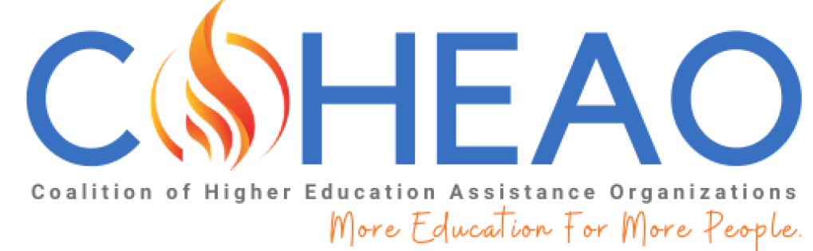

APPLICATION FOR THE COHEAO SCHOLARSHIP FOR THE
2024-2025 ACADEMIC YEAR

Please complete and email your entire application package in a PDF to coheaoscholarship@gmail.com. This application must be received by June 15, 2024, and all scholarship awards will be announced in August 2024. For information on eligibility requirements, please visit here.

Personal Information

Name
First Middle Last

University ID#
(If you receive a scholarship, we will include it with your check so that it may be credited to your student account.)

Street Address:

City: State: Zip Code:

Telephone #:
Daytime Evening

E-mail Address:

Check One:

I am a United States Citizen _____ I am not a United States Citizen ____

Educational Information

I will be enrolled full time in a degree program for the 2024/2025 Academic Year, and attend the following COHEAO member school or my parent is employed by the following COHEAO Commercial member:

School Name/Commercial Member:

Academic level for the 2024/2025 academic year: (please check)

Sophomore: Junior:
Senior: Graduate:

Anticipated date of graduation:

Current GPA (on a 4.0 scale):

Major Field of study:

Interests:

Special Recognition and Awards:

Community Involvement:

Academic Recommendation Information

Include one letter of recommendation on letterhead from a faculty member who is familiar with your academic skills:

Faculty Member’s Name:

Title:

Department:

Institution:

How do you know this person?

Original Official School Transcript

Please provide an official school transcript. Please obtain an official transcript and include it in the application package you will submit.

Essay

On a separate sheet of paper, in 300 words or less (typed, double-spaced) describe your future plans and goals as they relate to community service, and how a COHEAO scholarship will benefit you.

By signing this application, I am certifying the accuracy of the information provided on this application.

Signature ____________________________________ Date _______________________

COHEAO MEDIA CONSENT & RELEASE

THIS CONSENT & RELEASE (the “Release”), is made and entered into this date, ______________________ , by and between the Coalition of Higher Education Assistance Organizations of 777 Sixth St NW, Suite 510, Washington, DC 20001 (“COHEAO”) and [Name]_______________________________________________ an individual residing at [Address]____________________________________________________________________ (“INDIVIDUAL”).
WHEREAS, COHEAO wishes to use one or more photographs depicting INDIVIDUAL, and/or statements by, INDIVIDUAL for promotion and advertising, including in printed materials and on the Internet; and

WHEREAS, INDIVIDUAL consents to the use of the photograph(s) and/or statements by COHEAO.

NOW THEREFORE, INDIVIDUAL hereby unconditionally grants to COHEAO certain rights as described below.
1. INDIVIDUAL hereby irrevocably assigns to COHEAO: (a) the irrevocable, unrestricted and perpetual right throughout the world, to record, film, tape, video tape, photograph, broadcast (whether by wire, satellite, laser, cable or any other means whatsoever), reproduce, distribute, adapt, transmit, publicly perform, publicly display and otherwise use and make copies, in whole or in part, of one or more photographs depicting INDIVIDUAL alone or with a group, and/or statements by INDIVIDUAL, including without limitation, by incorporating said photographs and/or Statements in printed materials and posting on the COHEAO Internet web site; and (b) the irrevocable, unrestricted and perpetual right throughout the world to reproduce, distribute, transmit, print, publish and disseminate, in any medium whatsoever, INDIVIDUAL’s name, likeness and biographical information, including for the purposes of trade and/or advertising.

2. All right, title and interest in and to the photographs and/or statements, as between INDIVIDUAL and COHEAO, shall be the sole property of COHEAO, free from any claims whatsoever by INDIVIDUAL or any person deriving any rights or interests from INDIVIDUAL.

3. Notwithstanding the foregoing, COHEAO has no obligation or duty to use the photographs and/or statements in whole or in part.

4. INDIVIDUAL shall not receive any compensation in connection with: (a) the use and marketing of the photographs and/or statements; or (b) the exercise of the rights granted to COHEAO herein.

5. INDIVIDUAL hereby warrants that he/she is of full age and has the right to execute this Release. INDIVIDUAL further warrants and represents that, to the best of his/her knowledge and belief, INDIVIDUAL has not violated the rights of any third parties in executing this Release. INDIVIDUAL further warrants and represents that he/she will indemnify and hold harmless COHEAO, and its respective officers, directors, agents, attorneys, employees, affiliates, distributors, successors, licensees, and assigns from any and all losses, costs, and/or expenses arising out of a breach of the foregoing warranties. INDIVIDUAL represents that he/she has read this Release carefully and understand the contents. This Release shall be binding upon INDIVIDUAL and his/her heirs, legal representatives, and assigns.

INDIVIDUAL COHEAO

_________________________________ By:________________________________
Signature Signature

_________________________________ ___________________________________
Printed Name Title

_________________________________ ___________________________________
Date Date

Check List

Please make sure all the following has been completed and is included when submitting the scholarship application. Please submit one document containing all the needed information. (Incomplete applications will not be considered)

- Personal Information

  - Make sure to include your school id (not your social security number)

- Educational Information

- Academic Recommendation

- Original Official transcript

- Essay

- Sign your application

- COHEAO media consent and release

Submit your document containing the information required to coheaoscholarship@gmail.com .

Thank you,

Steven Kelly
Internal Operations Chair
COHEAO
coheaoscholarship@gmail.com

